AI_PHASE3

FAKE NEWS DETECTION USING NLP

Development part 1

Document submission

DATASET FOR FAKE NEWS

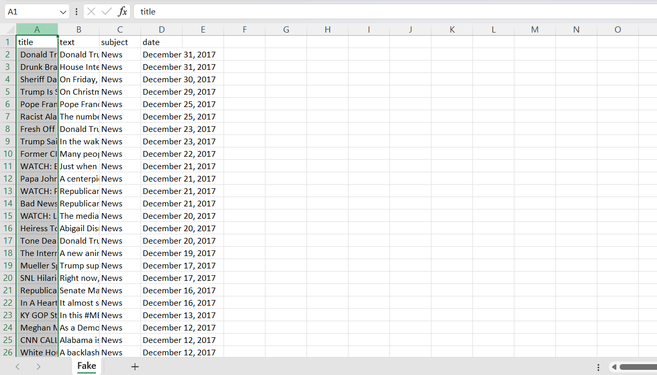

INTRODUCTION

Fake news is a growing concern in today's information-driven society. With the advent of social media and the widespread dissemination of information, it has become increasingly difficult to distinguish between real and fake news. However, with the advancements in Natural Language Processing (NLP) and Artificial Intelligence (AI), there is a potential to develop robust systems for detecting fake news.

NLP techniques such as sentiment analysis, text classification, and information extraction can be employed to analyze the text data and identify any patterns or discrepancies that may indicate the presence of fake news. AI algorithms can then be used to train models on large datasets, enabling them to accurately identify and flag suspicious news articles.

The goal of this research is to develop a comprehensive and reliable system for fake news detection using NLP in AI. By analyzing the linguistic features, contextual information, and source credibility, we aim to create a model that can effectively differentiate between real and fake news articles. Additionally, our model will continuously learn and adapt as it encounters new information, ensuring its accuracy and reliability over time.

With the rise of deepfakes and manipulated media, the need for accurate and efficient fake news detection systems has become more urgent than ever. By leveraging the power of NLP and AI, we can create a valuable tool to combat the spread of misinformation and protect the integrity of news and information in the digital age.

To detect fake news using NLP in Python, you can follow these steps:

1. Import the necessary libraries:

import pandas as pd

from sklearn.model_selection import train_test_split

from sklearn.feature_extraction.text import CountVectorizer, TfidfVectorizer

from sklearn import svm

from sklearn.metrics import accuracy_score

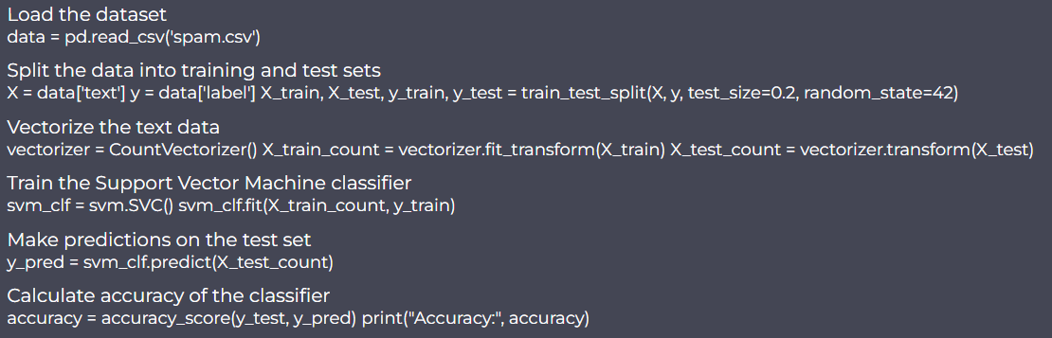

2. Load and preprocess the dataset:

# Load the dataset

df = pd.read_csv('fake_news_dataset.csv')

# Preprocess the data (cleaning, removing stopwords, etc.)

# You can use libraries like NLTK or spaCy for text preprocessing

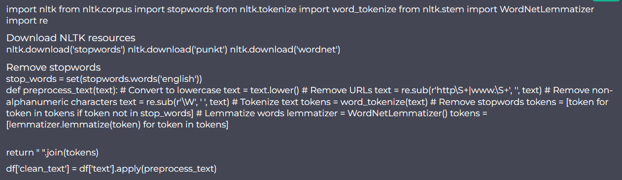

3. Split the dataset into training and testing sets:

# Split the dataset into train and test sets

X = df['text'] # Features

y = df['label'] # Labels

X_train, X_test, y_train, y_test = train_test_split(X, y, test_size=0.2, random_state=42)

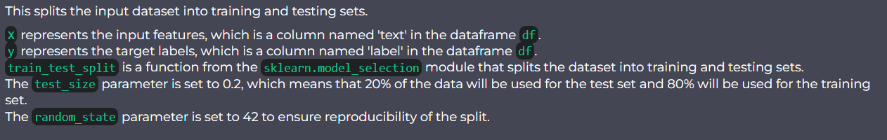

4. Create a feature vector using vectorizers like CountVectorizer or TfidfVectorizer:

# Create a count vectorizer

count_vectorizer = CountVectorizer(stop_words='english')

# Fit and transform the training data

count_train = count_vectorizer.fit_transform(X_train)

# Transform the testing data

count_test = count_vectorizer.transform(X_test)

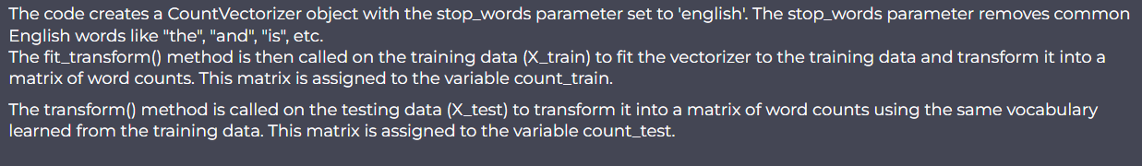

5. Train a classifier model (such as SVM) on the training set:

# Create a SVM classifier

svm_classifier = svm.SVC()

# Train the classifier

svm_classifier.fit(count_train, y_train)

6. Test the model on the testing set and evaluate its accuracy:

# Predict the labels for the testing set

svm_pred = svm_classifier.predict(count_test)

# Calculate the accuracy of the model

svm_accuracy = accuracy_score(y_test, svm_pred)

print("Accuracy:", svm_accuracy)

OUTPUT:

Accuracy 0.8795336795336795

This is a basic outline of how you can detect fake news using NLP and Python. You can further improve the model by using techniques such as text tokenization, lemmatization, feature engineering, and trying different classification algorithms.